STAYING ERGONOMIC #8
Ergonomics and Laptops
The design of a laptop (with the screen attached to the keyboard) can force users into a trade-off between poor neck/head posture and poor hand/wrist posture.
When the screen is at the right height to maintain good neck/head posture, the keyboard is too high which forces the user into bad hand/wrist posture.
When the keyboard is at the right height to maintain good hand/wrist posture, the screen is too low which forces the user into bad neck/head posture. Here are some quick tips to keep you ergonomic with your laptop:
- For Short Term Use - Take the laptop off your lap. Even though it is called a laptop you may not want to use it on top of your lap. This position requires you to slouch down with your head forward to see the screen, loading your cervical spine with dozens of extra pounds of pressure. If you must work without a desk, try utilizing a binder or a computer bag on your lap to elevate the screen and keyboard. This would be for intermittent use – not long term.
- For Long Term Use - Raise your screen. Elevate the laptop a few inches while on your desk. You can use books or a small box even. Your eyes should naturally hit the top third of your screen when looking straight ahead.
- Utilize a separate keyboard and mouse. Now that the screen is raised. Make sure you have an external keyboard and mouse in place. This allows you to keep your shoulders and arms relaxed and at a good neutral height for keying/mouse work.
- Increase font size. Leaning forward to view the screen can be mitigated by increasing font size. This will help avoid neck strain.
- Clean your screen periodically. Remove dust and dirt which will help reduce eye strain as well.
- Take your micro pauses. Remember the 20/20/20 rule. For every 20 minutes, take 20 seconds and focus on something 20 feet away. This is a good time to just stand up and take a quick stretch break.
- Properly manage cords. Laptops typically have power cords. Be aware of cord management to avoid trip hazards.
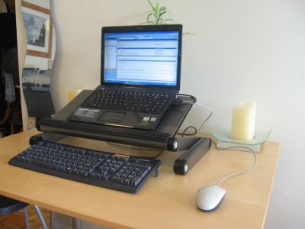

Ergonomic Laptop Setup Illustration
