STAY HOME & STAY ERGONOMIC #5
National Safety Month - Ergonomics
Every year the National Safety Council (NSC) promotes workplace safety throughout the month of June. This year millions of people have found themselves working from home during this unprecedented COVID-19 pandemic. The NSC has highlighted some unique challenges and safety concerns which we will be sharing with you throughout the month of June.
One of the first things the NSC has highlighted was Ergonomics and Working From Home. Whether you are working in a dedicated home office or at your kitchen table, good ergonomics is necessary to maintain overall health and help prevent back, shoulder and neck pain. Here are some quick tips to keep in mind from the Mayo Clinic:
- Adjust your chair so your feet rest on the floor and your knees are level or slightly below your hips. If your chair does not offer proper lumbar support, put a cushion or pillow between the curve of your back and the back of your chair. You can also use a rolled up small hand towel.
- Keep everything you will need for the day, including your phone and documents, close to you in a neutral zone to help avoid unnecessary reaching.
- Keep your keyboard and mouse on the same level and close to your body to mitigate outstretched reaching.
- Keep your wrist in a straight position – not bent up or down – when typing.
- Use a phone headset if you have one. This will prevent you from cradling the phone between your neck and shoulder. If not, try utilizing the speaker option on the phone.
- Keep your screen about an arm’s length in front of you.
- Be mindful of lighting. Avoid glare by keeping bright light sources to the side of your screen.
Below is a Take-A-Way stretching sheet you can refer to at your convenience. Post the sheet somewhere close to your workspace as a reminder to take quick micro pauses and stretch.
RESIG is here to assist you during this rapidly changing and challenging time. Please reach out via email with your ergonomic questions to:
Kelly Cook, CEAS, CPDM
Sr. Return to Work/Ergonomic Advisor, RESIG
kcook@resig.org

Be Well and Be Safe Everyone
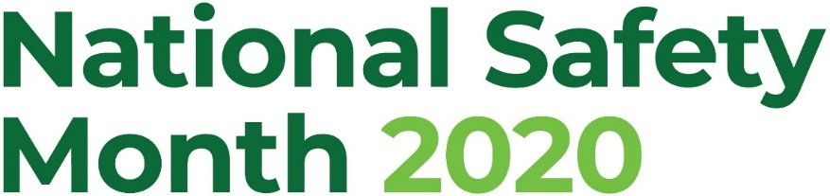
Take-A-Way Sheet
Quick Desk Stretches
