STAY HOME & STAY ERGONOMIC #7
National Safety Month – Back Safety

When you think about safe lifting practices what comes to mind? Is it the boxes of copy paper in the printer room or maybe the large containers of food product in the kitchens or maybe even lifting the trash bags out of the garbage cans and into the dumpsters? During your everyday home and work life think of how many items you might lift or carry throughout the day. Are you lifting safely?
HELP PROTECT YOURSELF WITH THESE FOUR STEPS:
- Size it up. Is the load light enough to be lifted by one person? If not, use a hand truck or ask for assistance. Check the container for exposed nails or staples that could cause injuries, and make sure you have a clear path to where you are moving the load.
- Safely lift. If the load can be lifted without assistance, first bring it as close to your body as possible. Lift with your legs – never with your back. Keep your head up and your back straight, and bend at the hips.
- Move with care. Keep the load close to your body as you walk and look ahead to be sure your path remains clear. Keep your nose in line with your toes – don’t twist and lift or twist and bend.
- Set down your load carefully. Squat with your knees or take a knee to lower the object down. Refrain from bending at the waist or worse twisting.
THINGS TO KEEP IN MIND:
- Do not attempt to lift by bending forward. Bend your hips and knees to squat down to your load, keep it close to your body, and straighten your legs to lift.
- Never lift a heavy object above shoulder level.
- Avoid turning or twisting your body while lifting or holding a heavy object.
- Consider partnered buddy lifting for heavier tasks.
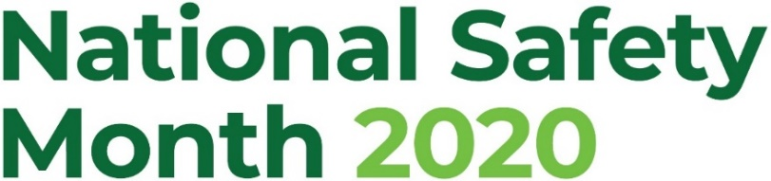

Safe Lifting Illustration
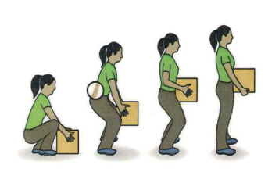
Use your knees/legs, keep the load close and your spine straight

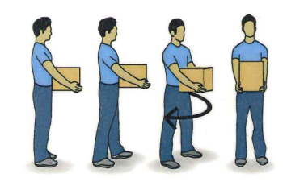
Don’t twist and bend. Keep your spine in a neutral position
Think about keeping your nose in line with your toes

