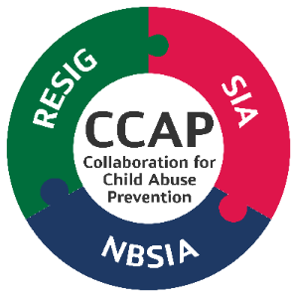
CCAP is a partnership of K-12 public schools pools, representing;
- 133 school districts and County Offices of Education across
- 12 counties,
- 57,000 school employees, and over
- 500,000 school children,
Together, our goal is to educate K-12 school son how to recognize and prevent child sexual abuse and, ultimately, to protect kids.

The weCARE program is a comprehensive toolkit, developed by CCAP, the Collaboration for Child Abuse Prevention, in conjunction with Diane Cranley, a renowned expert in sexual abuse prevention. The toolkit includes:
- An Education al Video Series aimed at helping school staff identify and report suspicious behaviors that may indicate adult sexual misconduct or child sexual abuse and develop best practices for the prevention of adult sexual misconduct and child sexual abuse in schools.

- A series of Discussion Guides to accompany each module of the Video Series and help facilitate discussions between staff about preventing child sexual abuse.

- Board Policy and Administrative Regulation recommendations to help school administrators develop policies to protect students from sexual abuse. (coming soon)

- Resources and Guidance for administrators, staff, parents and students.
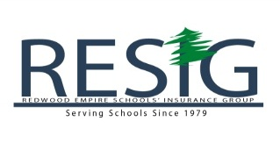

Educational Video Series:
Module 1: Introduction and Overview
Module 2: Grooming
Module 3: On-Site Isolation Boundaries
Module 4: On-Site Behavioral Boundaries
Module 5: Off-Site Behavioral Boundaries
Module 6: Off- Hours Behavioral Boundaries
Module 7: Electronic Social Media Boundaries
Module 8: Gift Boundaries
Module 9: Student-to-Student Boundaries

All Modules are tailored to the appropriate school level for elementary, middle and high school.

RESIG is actively participating in the Best Practices Coalition working towards development and adoption of a statewide policy for Best Practices in Prevention.

A variety of awareness materials will be sent to districts for all employees via email, written and electronic newsletters and website pages.

