I Job Title: II Grounds Worker

JOB ANALYSIS

I Department: I Maintenance

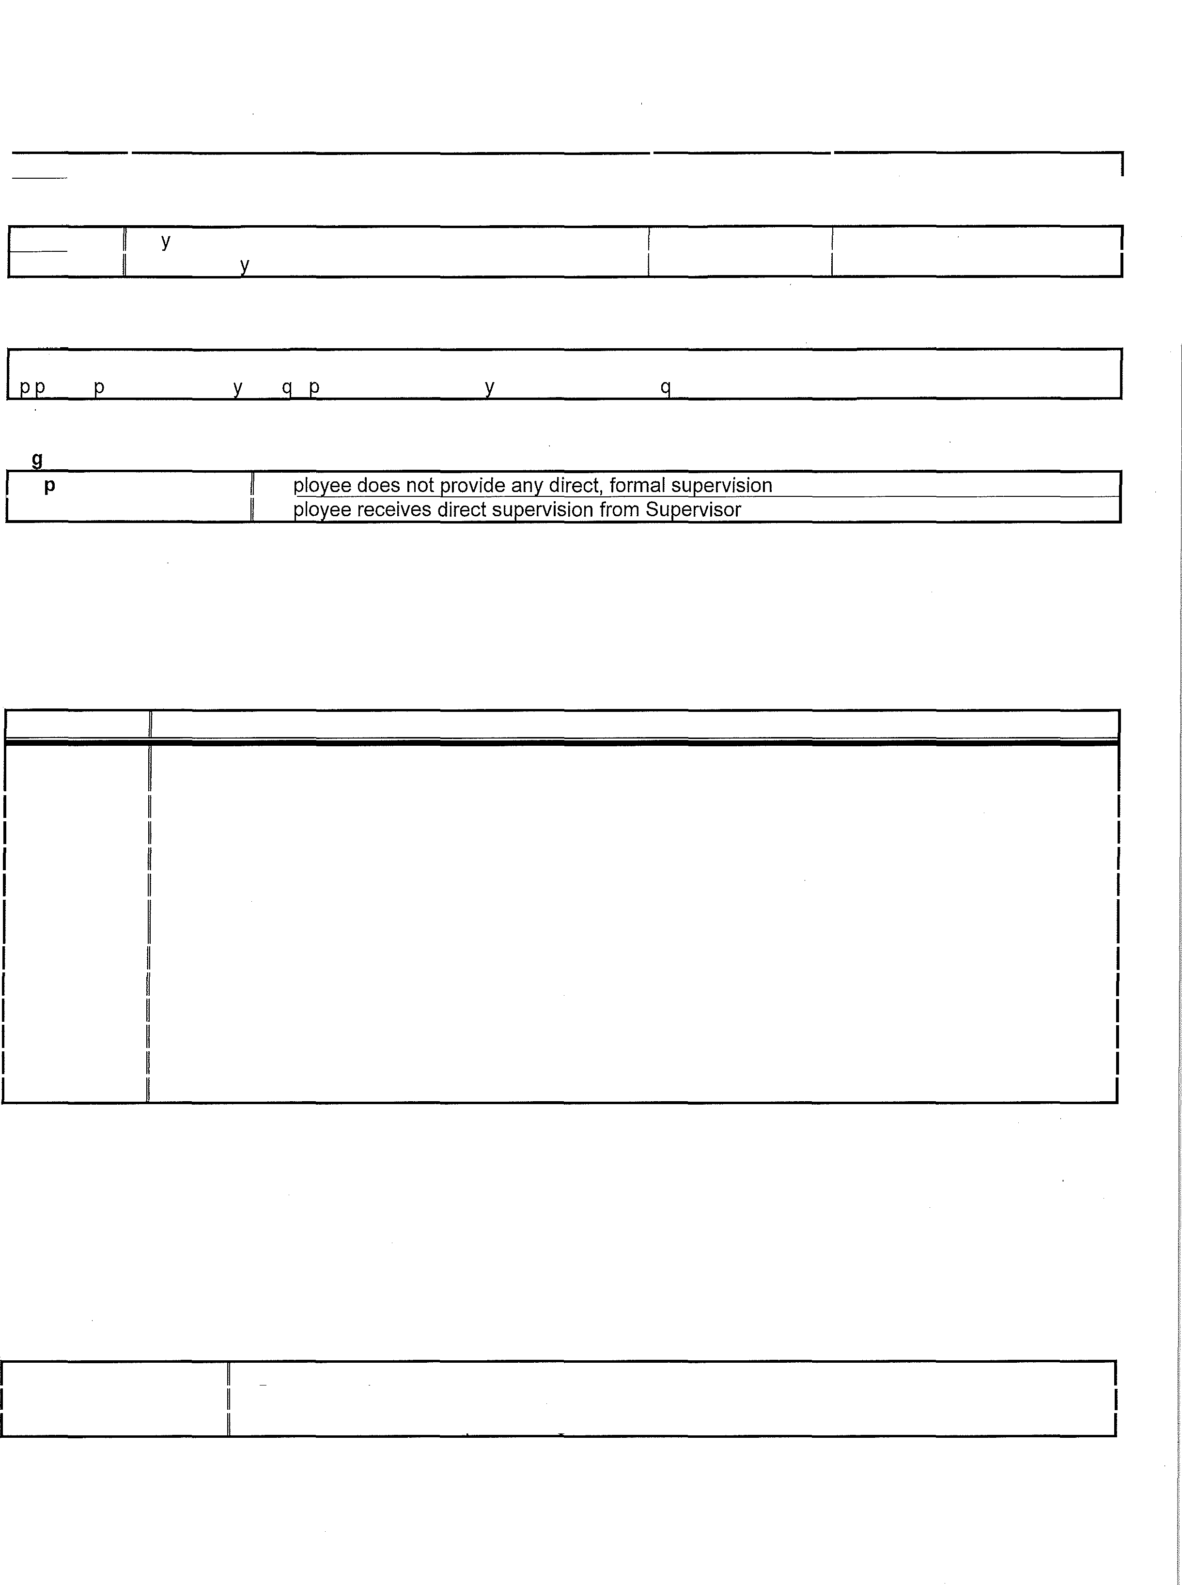
Shift: | Da s | Hours Per Shift: | 8
Overt | ime: Occasional! | Hours Per Week | 40

General Job Summary
Performs a variety of maintenance functions at assigned district sites. Maintains lawns, sprinkler systems, foliage, and i es. 0 erates a variet of e ui ment. Performs an related work as re uired.

Or anizational Relationships
Su ervision Given: Em Supervision Received: Em

Essential Job Functions
The job analysis will be reviewed periodically as duties and responsibilities change with business necessity. Essential and marginal (non-essential) job functions are subject to modification. Nothing in this job analysis restricts management's right to assign or reassign duties and responsibilities for this job.

Frequency Function
Completes a variety of maintenance functions such as mowing lawns/fields, weed whacking, edging,
Daily
trimming bushes/trees, removal and planting of trees/bushes, and re-seeding grass areas as needed.
Daily Checks and maintains sprinkler systems. Sets and adjusts sprinkler timers as needed.
Daily Applies fertilizer at assigned district sites.
Daily Maintains and properly stores all equipment and materials.
Daily May be assigned to a variety of special projects as the need arises. Operates shovels and related digginQ equipment to access pipes, sprinklers, and other underground
Daily
systems.
Daily Builds, installs, and maintains flower boxes.
Daily Operates a variety of tractors, vehicles, and equipment to perform assigned maintenance functions.
Daily Installs and maintains water piping as needed.
Daily Repairs and replaces pipes, valves, fittings, and other fixtures as assigned.
Daily Cleans out drains and obstructions in water and sewer systems.
Daily Performs a variety of other maintenance as assigned.

Non Essential Functions
None

Job Qualifications
Education: Hiqh school equivalent

Experience: NA
License/Certification CA driver's license, must pass backqround check

Job Title: Grounds Worker Page 2 of 6

Knowledge
- Clerical - Knowledge of administrative and clerical procedures and systems such as word processing, managing files and records, transcription, designing forms, and other office procedures and terminology.
- Customer and Personal Service - Knowledge of principles and processes for providing (internal or external) customer services including customer needs assessment, meeting quality standards for service, and evaluation of customer satisfaction.
- Design - Knowledge of design techniques, tools, and principles involved in production of precision technical plans, blueprints, drawings, and models.
- Engineering and Technology - Knowledge of the practical application of engineering science and technology. This includes applying principles, techniques, procedures, and equipment to the design and production of various goods and services.
- Maintenan�e - Knowledge of maintenance, general construction, use of tools/equipment
- Mathematics - Knowledge of arithmetic, statistics, and their applications.
- Mechanical - Knowledge of machines and tools, including their designs, uses, repair, and maintenance.

Skills
- Active Learning - Understanding the implications of new information for both current and future problem-solving and decision-making.
- Active Listening - Giving appropriate attention to what other people are saying, taking time to understand the points being made, asking questions as appropriate, and not interrupting at inappropriate times.
- Attention to Detail - Maintaining appropriate attention to detail based on the complexity of work performed.
- Communication and Comprehension - Conveying written and/or non-written information effectively; comprehending and understanding documentation and verbal or visual communications.
- Complex Problem Solving - Identifying complex problems and reviewing related information to develop and evaluate options and implement solutions.
- Critical Thinking - Using logic and reasoning to identify the strengths and weaknesses of alternative solutions, conclusions or approaches to problems.
- Equipment Maintenance - Performing routine maintenance on equipment and determining when and what kind of maintenance is needed.
- Construction - Basic carpentry and construction skills
- Equipment Selection - Determining the kind of tools and equipment needed to do a job.
- Installation - Installing equipment, machines, wiring, or programs to meet specifications.
- Mathematics - Using mathematics to solve problems.
- Operation, Monitoring and Control - Watching gauges, dials, or other indicators to make sure a machine is working properly; controlling operations of equipment or systems.
- Repairing - Repairing machines or systems using the needed tools.
- Time Management - Managing one's own time and the time of others.

Abilities
- Category Flexibility - The ability to generate or use different sets of rules for combining or grouping things in different ways.
- Deductive Reasoning - The ability to apply general rules to specific problems to produce answers that make sense.
- Time Sharing - The ability to shift back and forth between two or more activities or sources of information.

Analysis prepared by DMG (3/3/16) 1850 Gateway Blvd., Suite 275 - Concord, CA 94520
www.dmgworks.com

Job Title: Grounds Worker Page 3 of 6

Physical Demands
Never (N) Rare (R) Occasional (0) Frequent (F) Constant (C)

L"Ift.mg

Not Required
Less than 10% of the shift Up to 33% of the shift
Up to 66% of the shift Over 66% of the shift

Weight Range | Frequency |  |  |  |  | Examples of Items Lifted | Height Lifted | Item Weighed
 | N R |  | 0 F |  | C |  |  | y | N
0-10 lbs |  |  |  | X |  | Hand tools, loose supplies/materials, phone, keys, power tools 1-6' |  | y
11-25 lbs |  |  | X |  |  | Power tools, materials, bushes, shovels, debris, piping, various 1-6' y materials
26-50 lbs |  |  | X |  |  | Power tools, materials, weed whacker, piping, various materials 1-6' y
51-75 lbs | X
76-100 lbs | X
Over 100 lbs | X
Heaviest Item Lifted |  |  | X |  |  | Various lumber/materials 1-5' y
Notes regarding items weighed (if any): None

Carrying
Weight Range | Frequency |  |  |  |  | Examples of Items Carried | Distance Carried | Item Weighed
 | N | R 0 F |  |  | C |  |  | y | N
0-10 lbs |  |  |  | X |  | Hand tools, loose supplies/materials, phone, keys, power tools | 1-100' | y
11-25 lbs |  |  | X |  |  | Power tools, materials, bushes, shovels, debris, piping, various materials | 1-100' | y
26-50 lbs |  |  | X |  |  | Power tools, materials, weed whacker, pipinq, various materials | 1-50' | y
51-75 lbs | X
76-100 lbs | X
Over 1001bs | X
Heaviest Item Carried |  |  | X |  |  | Various lumber/materials | 1-50' | y

Notes regarding items weighed (if any): None

Analysis prepared by DMG (3/3/16) 1850 Gateway Blvd., Suite 275-Concord, CA 94520
www.dmgworks.com

Job Title: Grounds Worker Page 4 of 6

Category | Frequency |  |  |  |  | Surface(s) | Activity
 | N | R | 0 F |  | C
Sittinq |  | X |  |  |  | Vehicle seat, floor ground | Operating vehicle, working near floor/ground
Walking |  |  |  | X |  | Carpet, linoleum/tile, concrete, outdoor terrain, asphalt | Transporting materials, gathering tools/supplies, performinq maintenance/repairs
Standing |  |  | X |  |  | Carpet, linoleum/tile, concrete, outdoor terrain, asphalt | Accessing materials/supplies/tools, operating hand and power tools, performing maintenance

Category Frequency
Activity

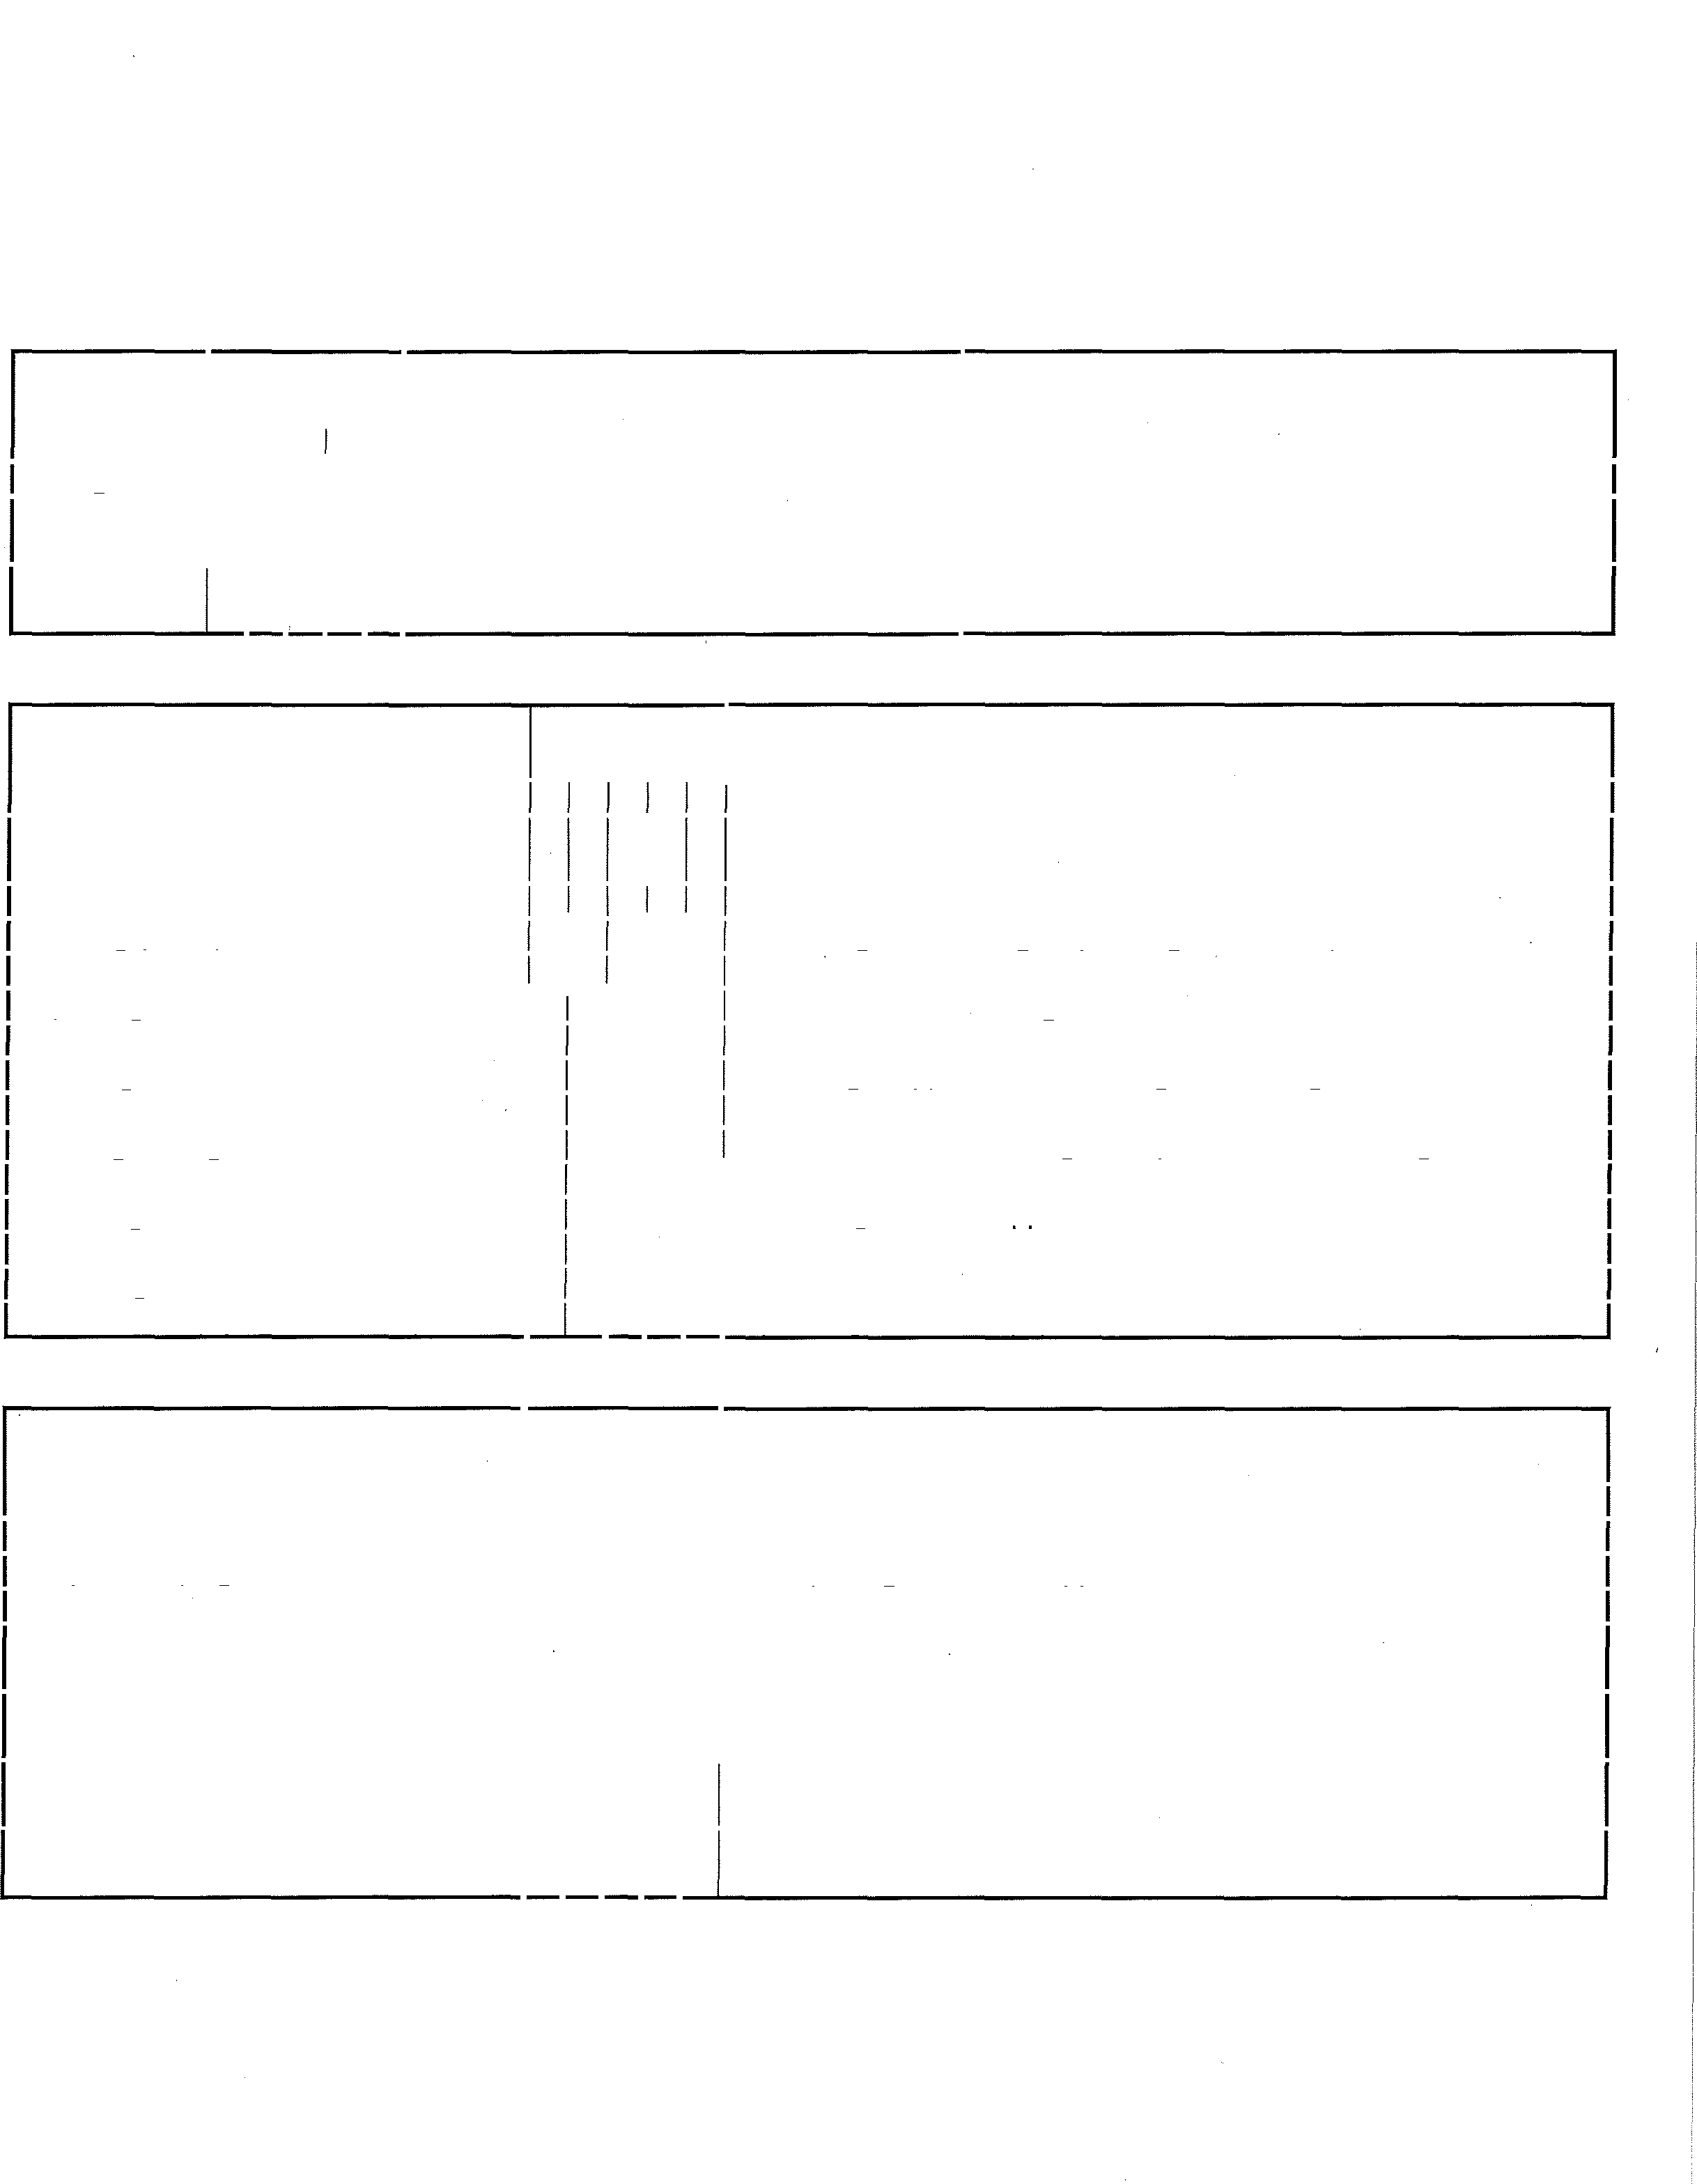 N R 0 F C
Bending (Neck) x-x Observing work/documents, inspections, operating hand/power
tools
Bending (Waist) X Reaching low drawers/shelves, working near floor/ground
Twistinq (Neck) |  | X |  |  | Observinq surroundinqs, operatinq vehicles/equipment
Twisting (Waist) |  | X |  |  | Accessing supplies/materials, performing maintenance
Squattinq |  |  | X |  | As alternative to b,endinq
Climbing | X |  |  |  | Stepstool, ladder
Kneelinq |  |  | X |  | Obtaininq dropped items, workinq near floor/qround
Crawling |  |  | X |  | Obtaining dropped items, working near floor/ground
Pushinq/Pullinq (Dominant hand) |  |  |  | X | Drawers/doors, cart, usinq hand/power tools, installinq materials
Pushing Pulling (Non-Dominant hand) |  |  |  | X |  | Drawers/doors, cart, using hand/power tools, installing materials
Reachinq - Above Shoulder Level |  |  | X |  |  | Accessinq items on uooer shelves
Reaching - Below Shoulder Level |  |  |  | X |  | Operating vehicle, performing maintenance/installations
Balancinq | X |  |  |  |  | Ladder
Coordination (Eye, Hand, Foot) |  |  | X |  |  | Operating vehicles/equipment

Category | Frequency |  |  |  |  | Activity
 | N | R | 0 | F | C
Repetitive Use of Hands |  |  |  | X |  | Operating hand/power tools, performing repairs/maintenance
Simple Graspinq (Dominant Hand) |  |  | X |  |  | Transportinq materials/supplies
Simple Grasping (Non-Dominant Hand) |  |  | X |  |  | Transporting materials/supplies
Power Grasping (Dominant Hand) |  |  |  | X |  | Transporting heavier materials/supplies, operating power tools, performinq repairs/maintenance
Power Grasping (Non-Dominant Hand) |  |  |  | X |  | Transporting heavier materials/supplies, operating power tools, performing repairs/maintenance
Fine Manipulation (Dominant Hand) |  |  |  | X | Operating hand tools, operating equipment, performing maintenance
Fine Manipulation (Non-Dominant Hand) |  |  |  | X | Operating hand tools, operating equipment, performing maintenance

Analysis prepared by DMG (3/3/16) 1850 Gateway Blvd., Suite 275 - Concord, CA 94520
www.dmgworks.com

Job Title: Grounds Worker Page 5 of 6

Environmental Demands
Factor y•

N If yes, describe

Driving cars, trucks, forklifts and other equipment
D Company vehicle, tractor, lifts

•
Working around equipment and machinery D Power tools, tractor, lifts

Walking on uneven ground
D Ramps, outdoor locations

•
Exposure to excessive noise D Power tools, machinery/equipment

Exposure to extremes in temperature, humidity, wetness
D Outdoor conditions

•
Exposure to dust, gas, fumes, or chemicals D Dust

Working at heights
D Ladder, scaffold, roof tops
•
Operation of foot controls or repetitive foot movement D Driving
•

Use of special visual or auditory protective equipment Working with bio-hazards
D Gloves, safety glasses
D Waste products

sensory Demands
Factor y•

N If yes, describe

Seeing close (inspecting)
Seeing far (observing) D Monitoring work area, operating vehicles
D Operating hand/power tools, observing work

•

Seeing to sides (peripheral vision)
Seeing colors D Electrical wiring
D Monitoring work area, operating vehicles

•

Speaking
Hearing Speech D Communicating with co-workers
D Communicating with co-workers

•

Hearing mechanical sounds
Sensing odors D Inspections

Sensing touch
D Operating power tools

•
D Inspections

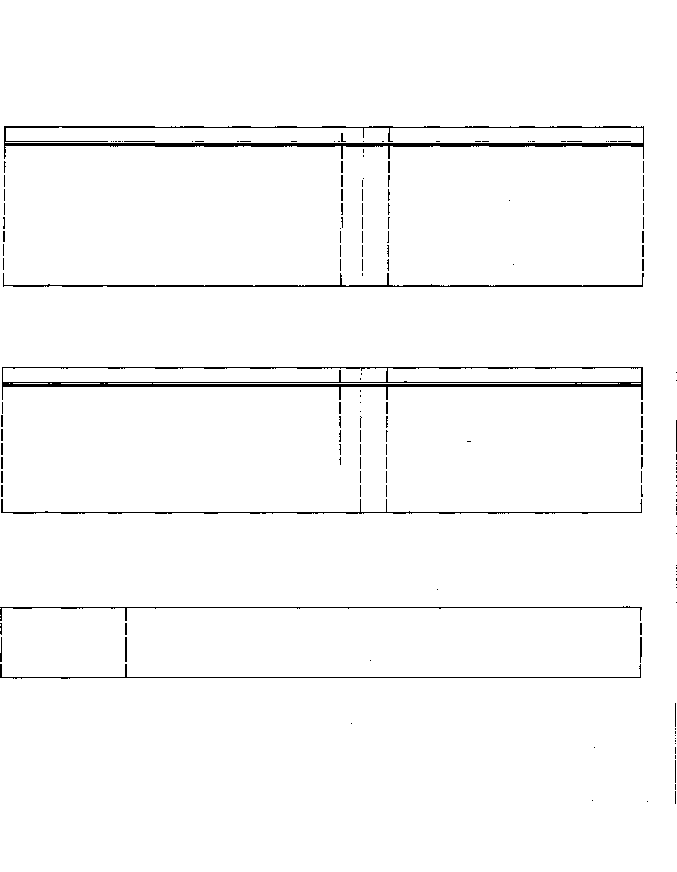

MachineryIj Equipment/Work A1"ds
Machinery Lifts, tractor
Equipment Phone, computer
Tools Screwdriver, hammer, saw, wrench, pliers, drills, compressor, variety of other hand/power tools as
needed Other Work Aids None

Analysis prepared by DMG (3/3/16) 1850 Gateway Blvd., Suite 275 - Concord, CA 94520
www.dmgworks.com

Job Title: Grounds Worker Page 6 of 6

Required

MENTAL/COGNITIVE DEMANDS Yes/No
y N
•
Relate to other people D

•
Perform daily activities (ex. ability to attend meetinqs, socialize with others, attend to personal needs, etc.) D
Maintain personal habits D
i •
Multitask relative to
ob duties D
Understand, carry out, and remember instructions D

•
Respond appropriately to supervision D
Perform work requirinq reqular contact with others D

•
Perform work where contact with others will be minimal D
Perform tasks requirinq minimal intellectual effort D

•
Perform intellectually complex tasks requirinq hiqher levels of reasoninq, math and lanquaqe skills D
Perform repetitive tasks • D
Make independent judqment • D•
Perform varied tasks D
Supervise or manaqe others D •
•

Provide clinical direction
Perform under stress (emergency, critical, dangerous situations);

speed/sustained attention are make-or-
D• D

break aspects of the job
j D
Ability to work relative to the ob description

NOTE:

This Employer is an equal opportunity employer. In compliance with the Federal and State disability laws, this employer has a responsibility to consider reasonable accommodations for individuals with disabilities.

Analysis prepared by DMG (3/3/16) 1850 Gateway Blvd., Suite 275 - Concord, CA 94520
www.dmgworks.com

